**Assignment 7 (40 points)**

**Goutham Selvakumar (2092286)**

**Problem 1. Review of the main topics from image processing *(10/10)***

**Briefly describe each one of the topics below. In your descriptions, include the advantages/disadvantages of each approach and an example of an application where the approach can be applied:**

* **Sampling:-**
* The sampling rate determines the spatial resolution of the digitized image and also digitizes the co-ordinate value of an image.
* It has a relationship with the image pixels. So, the more the samples in the image it will result in more pixels which will eventually result in better image quality with less noise present.

**[Pixels = total no of rows * total no of columns]**

* **Advantages**:-
  + It allows us to gather data that you wouldn’t be able to gather.
* **Dis-Advantages**:-
* If the frame is large, random sampling may be impractical.
* **Applications**:-
  + Can be implemented on High Speed Streak Cameras.
* **Quantization:-**
* It is the opposite of sampling, when quantizing an image, we are actually dividing a signal into partitions.
* It digitizes the amplitude value of the image.
* Furthermore, if we want to improve the quality of image, we can increase the levels assigned to the sampled image.
* **Advantages:-**
  + Quantization, in essence, lessens the number of bits needed to represent information. Lower-precision mathematical operations, such as an 8-bit integer multiply versus a 32-bit floating point multiply, consume less energy and increase compute efficiency, thus reducing power consumption.
* **Dis-Advantages:-**
  + Lossy Compression technique is used.
* **Applications:-**
  + Can be used on US money (integral multiples of pennies).
  + Used for musical instruments like a piano (or) trumpet.
* **Histogram Equalization:-**
* Histogram Equalization is a method to process images in order to adjust the contrast of an image by modifying the intensity distribution of the histogram.
* The objective of this technique is to give a linear trend to the cumulative probability function associated to the image.
* **Applications**:-
* It can be used in Digital X-Rays, MRIs, and CT scans.
* **Advantages**:-
  + - Histogram Equalization is the best method for image enhancement.
    - It provides with better quality of images without loss of any information.
* **Dis-Advantages:-**
  + - However, in some type of images histogram equalization can show some hidden noise after the processing is done.
* **Laplacian of Gaussian (LoG) edge detection:-**
* LoG is useful for detecting edges that appear at various image scales or degrees of image focus.
* The exact values of sizes of the two kernels that are used to approximate the Laplacian of Gaussian will determine the scale of the difference image, which may appear blurry as a result.
* **Advantages**:-
  + Useful for finding edges
  + Useful for finding blobs
* **Dis-Advantages:-**
  + It amplifies noise in the image
* **Applications:-**
  + Can be used for Blob Detection.
* **Dilation:-**
* The dilation process is similar to the convolution process, that is, the structuring element is reflected and shifted from left to right and from top to bottom, at each shift; the process will look for any overlapping similar pixels between the structuring element and that of the binary image.
* This structuring element is smaller in size compared to the image itself, and normally the size used for the structuring element is 3 x 3.
* **Advantages:-**
  + Increases the brightness of the objects.
  + It fills the holes and broken areas.
  + Used later in Opening Operation.
* **Dis-Advantages:-**
  + Increases the size of the objects.
* **Applications:-**
  + Broken Characters can be repaired
* **Erosion:-**
* Erodes away the boundaries of the foreground object.
* Used to diminish the features of an image.
* **Advantages:-**
  + It removes the small anomalies.
  + It removes the objects smaller than the structuring element.
  + Used later in Closing Operation.
* **Dis-Advantages:-**
  + It reduces the brightness of the bright objects.
* **one topic not in the list above that you enjoyed:-**
* **Image Segmentation:-**
* This is a common technique in image processing and analysis to partition an image into multiple parts (or) regions, often based on the characteristics of the pixels in the image.
* **Applications**:-
* Medical Imaging, Autonomous Driving.

**Problem 2. Segmentation overview *(10/10)***

**Briefly describe the segmentation techniques learned in this course and the relationships, if any, among them. You can also include a diagram to show the relationships. Pick one of these techniques and describe one application where you think it will be appropriate to use the technique.**

* **Segmentation:-**
  + Image segmentation is a method of dividing a digital image into subgroups called image segments, reducing the complexity of the image and enabling further processing (or) analysis of each image segment.
* **Histogram-Based Segmentation.**
* **Edge-Based Segmentation.**
* **Applications:-**
  + It helps locate features of associated objects in the image using the information from the edges. Edge detection helps strip images of redundant information, reducing their size and facilitating analysis.
  + Edge detection is used for image segmentation and data extraction in areas such as image processing, computer vision, and machine learning.

**Problem 3. *(10/10)***

**The image in Figure 1(a) below shows a gray level image. The images in the other parts correspond to low-passed, high-passed, or band-passed version of (a), not necessary in that order. Identify which of the images in (b), (c), and (d) is low-pass, which one is band-passed, and which one is high-passed? Justify your choices.**

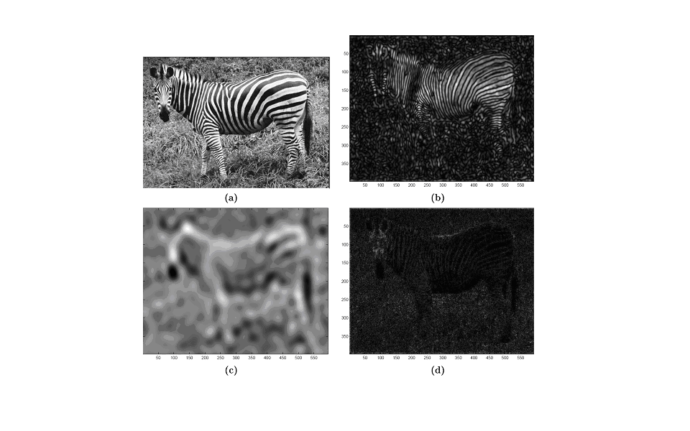

Figure 1: Figure for Problem 2

* From the above image, we can figure it out that the low-passed fi lter is based on the image (b), high-passed filter is based on the image(c), and band-passed filter is based on the image (d).
* **Low-passed filter** only allows low frequency details.
* **High-passed filter** allows passing only high frequency details.
* **Band-passed filter** allows signals within a certain band to pass.

**Problem 4. *(10/10)*:**

**Describe an algorithm to locate all of the large boxes in the image (Figure 2) below.**



Figure 2: Image for Problem 4

* The first step would be to search the image for any major of the boxes that might be there. Once the first step is done, we would then detect the edges of the large boxes and then trace those edges. The final step involves that the large boxes are individually found and labelled for all the four corners. However, the first thing would be to search the image for any large boxes that can be found.
* First method in this method is done by searching the image for a specific areas in relation to the pixels around the area having a unique difference in tone, with being darker (or) lighter.
* Furthermore, the algorithm starts by finding a very large box, after finding the large box, finding the edges of the box are next. One way of doing it, is done by following the border of the lighter (or) darker areas with a pencil (or) pen.
* The co-ordinates of the large four box corners are the final stage of the algorithm. So, this method can be succeeded by finding out the spots on the large box’s borders under which the two sets of borders connect with one another.